France & Belgium Military History Tour
June 2014

Major Mike Peters, Military Historian

WW I Western Front and WW II – Dunkirk and Normandy Beaches,
Waterloo and Agincourt Battles
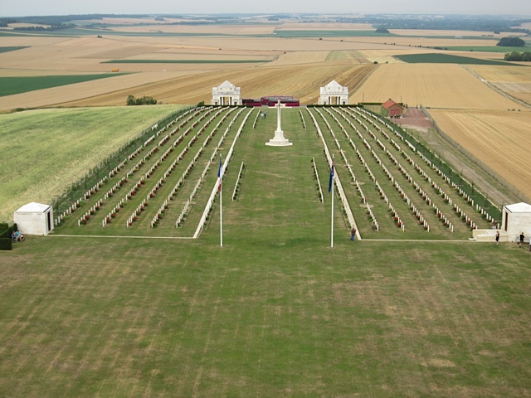

Final Itinerary
Day 1 – Saturday 14 June - Paris
Members of our group will check in independently at our 4 star Waldorf Trocadero Hotel during Saturday unless separate arrangements have been made to check in earlier.
6.00 pm – we will rendezvous in the hotel bar for a drink before walking to a nearby Paris restaurant for our get together welcome dinner.
WALDORF TROCADERO HOTEL (2 nights)
97 RUE LAURISTON, PARIS, 75116,
Tél. + 33 1 45 53 83 30
http://www.hotelwaldorftrocadero.com

Day 2 – Sunday 15 June - Paris
Breakfast at hotel now included as part of room tariff
9.00 am – Assemble in hotel lobby
We will walk across The Seine River and under the Eiffel Tower to visit the world famous French Army Museum, and the tomb of that great bad man, Emperor Napoleon Bonaparte.
While the rest of today is at leisure exploring Paris, there will be an option of having lunch together and visiting the nearby Musee d’Orsay in the afternoon. David Cooper will conduct the tour this day.
6.00 pm – Assemble in Hotel Lobby for drinks and meet tour guide, Major Mike Peters. From there we will travel (probably walk) to a nearby Paris restaurant
Day 3 – Monday 16 June - Brussels
Breakfast at hotel now included as part of room tariff
9.00 am – Assemble in lobby from where we drive from Paris to Brussels. David Cooper will pick up the Mercedes Bus that morning from Gare du Nord and return to hotel for pick up.
We will follow the same route taken by Napoleon in 1815. On arrival enjoy free time exploring the delightful streets, restaurants and bars of the Belgian capital.
6.00 am – assemble for drinks prior to dinner at hotel (note each room has an Euro 80 hotel voucher to be used for dinner and drinks).
Hotel Amigo Brussels (2 nights)
The Rocco Forte Hotels
Rue de l'Amigo 1-3
Tel: +32 2 547 4707
www.roccofortehotels.com/hotels-and-resorts/hotel-amigo/

Day 4 – Tuesday 17 June - Waterloo 1815 - Field of Glory
Breakfast at hotel covered as part of package
9.00 am – Assemble in lobby for departure to Waterloo.
On this date, the eve of the 199th anniversary of the battle of Waterloo, we will walk across the battlefield where the long term fate of Europe was decided in one single bloody day. Spend today immersed in the titanic struggle that saw the French Army of the North, commanded by the charismatic genius that was Napoleon Bonaparte, pitched against the Anglo-Dutch Armies commanded by the tactically skilled Duke of Wellington, and the vengeful Prussians led by Marshal Blucher. Over the course of our day, the story of that fateful and bloody Sunday afternoon will be brought to life. Finally, we will follow in the footsteps of the massed columns of French Infantry and the hoof marks of Marshal Ney's cavalry to the high water mark of Napoleon's imperial ambition. At this point, the hidden secrets of the field of Waterloo will be revealed. Our day will include visits to Wellington’s Headquarters Museum, Napoleon’s Headquarters Museum, the Waterloo Panorama, The Lion Mount Memorial/Viewing Point, Battlefield Walk and Hougoumont Farm.
Return for our final night in Brussels
6.00 am – drinks in hotel lobby bar prior to departure to restaurant for dinner
Day 5 – Wednesday 18 June - Ypres 1914 and The Contemptible Little Army
Breakfast at hotel covered as part of package
8.30 am – Assemble in Lobby to leave Brussels
We will cross the cockpit of Europe to a small, peaceful, Belgian town - a town whose name was once infamous across the English speaking world. This is the town of Ypres. In the Grand Market Square, in the shadow of the magnificent Medieval Cloth Hall, we will explore the Menin Road, the main artery of what was to later to be named the Immortal Salient. This road dissects the fiercely contested battlefields of the first battle of Ypres in the autumn of 1914. It was in the fields around Ypres that the British Tommy nicknamed Ypres 'Wipers' and witnessed the destruction of the First British Expeditionary Force. We will spend our afternoon looking at the battles fought by the BEF, a force that the German Kaiser referred to as 'that Contemptible Army' - a small, highly trained force, which fought valiantly to stem the advance of an almost irresistible tide of German regiments. Our day concludes at the scene of the Christmas truce of 1914. Included sightseeing comprises Gheluvelt 1914 - Battle Site, Langermarck German Cemetery, The Aristocrats Cemetery and the Scene of the Christmas Truce.
Check in our hotel
6.30 pm – Drinks at Hotel
7.30 pm – Walk to Menin Gate for 8.00 pm Last Post
8.30 pm – Dinner at Restaurant
Albion Hotel (4 nights)
St. Jacobsstraat 28, 8900 Ieper
Tel.: 0032 57 200 220
http://www.albionhotel.be

Day 6 – Thursday 19 June - Dunkirk & The Blitzkrieg 1940
Breakfast at hotel covered as part of package
8.30 am – Assemble in lobby for departure to Dunkirk.
The strategic location of Ypres has ensured that it is no stranger to war, invasion and siege. In the summer of 1940 Ypres was again in the path of an invading German Army. Today we will look at the momentous events of the summer of 1940. We will follow the hard pressed soldiers of the Second BEF as they withdrew through the graveyards of their forbears, across Belgian Flanders, with the Panzers of the German Army and the relentless Stukas of the Luftwaffe in pursuit. We will follow the British retreat and include visits to some of the small towns where critical rearguard actions were fought by BEF troops as they attempted to delay the German Blitzkrieg. Today culminates with a visit to the Bray Dunes, scene of the evacuation, a visit to the Dunkirk Museum and finally, the Dunkirk Memorial and the Operation Dynamo exhibition. We will then return directly to our hotel in Ypres in time to attend the emotive Last Post Ceremony at the Menin Gate.
6.30 pm – Drinks at Hotel
7.30 pm – Walk to Menin Gate for 8.00 pm Last Post (optional)
8.30 pm – Dinner at Restaurant
Day 7 – Friday 20 June - The Second Battle of Ypres 1915 - Darkness and Flame
Breakfast at hotel covered as part of package
9.00 am – assemble in Lobby for coach departure.
Today we are very much back in the midst of the Great War and will look at the series of events that were described as 'the death of chivalry'. Not long after the Christmas Truce the German Army launched a new offensive that would later be known as the Second Battle of Ypres. A desperate attempt to break the deadlock of trench warfare, this was a struggle that would witness the use of new and horrifying weapons. We will visit Hooge Crater Museum & Trenches, Hill 60, Vancouver Corner (where the Canadians faced the first use of gas), the Shot at Dawn Memorial and the Talbot House Museum at Poperinghe.
6.30 pm – Drinks at Hotel
7.30 pm – Walk to Menin Gate for 8.00 pm Last Post (optional)
8.30 pm – Dinner at Restaurant
Day 8 – Saturday 21 June - Passchendaele, The Third Battle of Ypres
Breakfast at hotel covered as part of package
9.00 am – assemble in Lobby for coach pick up.
Before we move south to explore the battlefields of the Somme region we spend a day looking at the huge efforts and terrible cost of the British 1917 offensive. The big push of July 1917 involved men from every corner of the British Empire and Commonwealth. We will examine the thinking behind this gigantic offensive, its conduct and the terrible cost. Here we will visit Messines Ridge, Polygon Wood, the New Zealand Memorial at Gravenstafel, Crest Farm, the Canadian experience of Passchendaele, the newly opened Passchendaele Museum and Tyne Cott CWGC - The Largest CWGC cemetery in the world.
6.30 pm – Drinks at Hotel
7.30 pm – Walk to Menin Gate for 8.00 pm Last Post (optional)
8.30 pm – Dinner at Restaurant
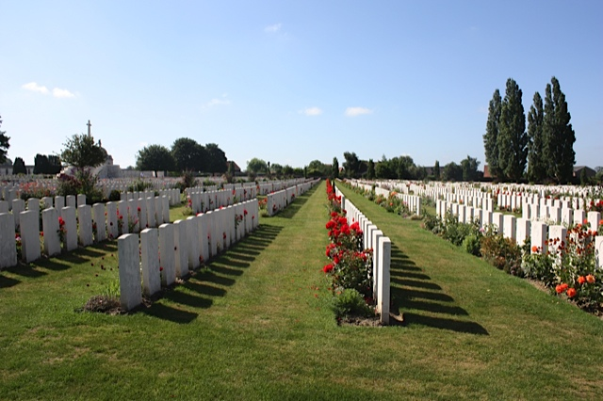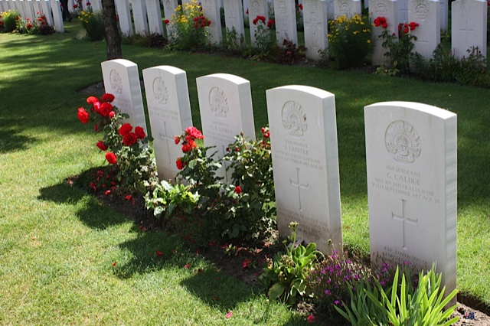
Day 9 – Sunday 22 June - French Flanders and the Somme
Breakfast at hotel covered as part of package
9.00 am – Assemble in Lobby for departure from Ypres
This morning leave Ypres and head south to Arras passing through two very different battlefields. Our first stop will be at Fromelles, a battlefield forever associated with the needless sacrifice of the 5th Australian Division. Here, we will spend the morning looking at the controversial handling of Australian troops in their first significant action on the Western Front. In the afternoon, we continue to head south to the small village of Agincourt, scene of the English victory over the French immortalised in song, poem and celluloid.
6.00 pm – Assemble for Drinks in Hotel Lobby
7.00 pm – Dinner at Restaurant
Holiday Inn Express (3 nights)
3 Rue du Dr Brassart 62000 Arras – France
Téléphone: +33 (0) 3 21 60 88 88 I
www.holidayinn-arras.com

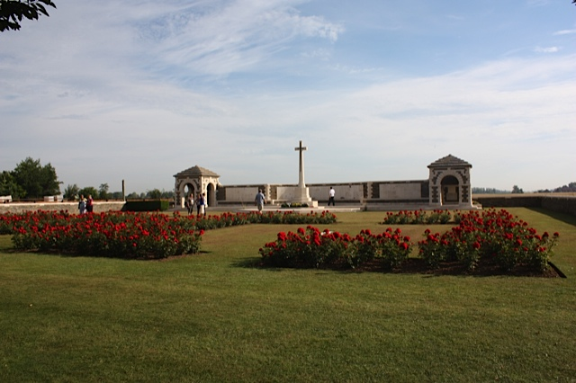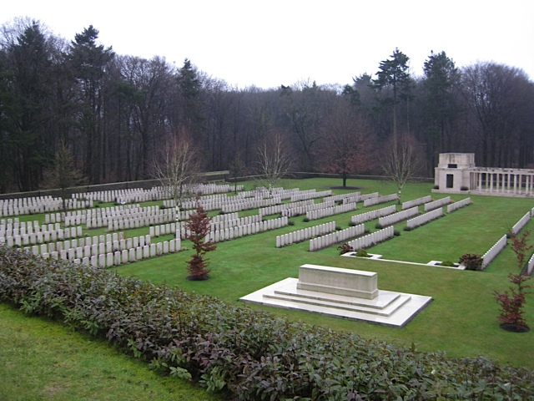
Day 10 – Monday 23 June - The Somme Offensive of 1 July 1916
Breakfast at hotel covered as part of package
9.00 am – assemble in Lobby for coach pick up.
The Somme offensive was launched in a spirit of great optimism on 1 July 1916. Yet, the disaster that followed was later described as the blackest day in the history of the British Army. We will walk over the fields that witnessed the near destruction of Kitchener's New Citizens’ Army and gain an understanding of what went wrong, charting the events that led to 60,000 casualties in a single catastrophic day. We will visit various sites and museums near Arras including Flying Services Memorial, Wellington Quarry underground museum, Battlefield walk, Ulster Tower & Thiepval Wood Trenches, Pozieres, Lochnaghar Crater, Thiepval Memorial and the Missing & Visitor Centre.
Return to Holiday Inn at Arras
6.00 pm – Assemble for Drinks in Hotel Lobby
7.00 pm – Dinner at Restaurant
Day 11 – Tuesday 24 June - ANZACs on the Somme
Breakfast at hotel covered as part of package
9.00 am – Assemble in Lobby for coach departure
Our final day on the Somme will focus on the achievements of the ANZACs and the momentous events of 1918. There will also be time to visit the field where the mortally wounded Red Baron, Manfred von Richtofen, landed his plane. The question is...who shot him down? Sightseeing inclusions: the original resting place of the Australian Unknown Soldier, Villers Bretoneux - Australian National Memorial and Museum, Le Hamel - Australian Corps Memorial and Corbie Plateaux.
Return to Holiday Inn at Arras
6.00 pm – Assemble for Drinks in Hotel Lobby
7.00 pm – Dinner at Restaurant
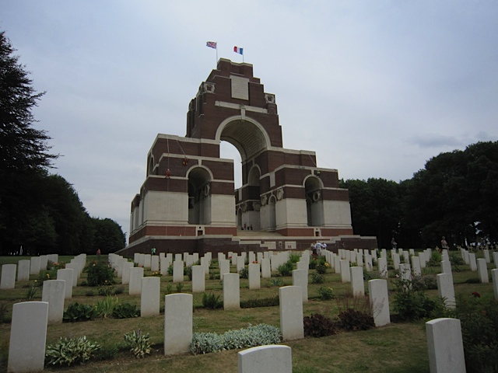
Day 12 – Wednesday 25 June - Travelling forward in time from Arras to Normandy
Breakfast at hotel covered as part of package
9.00 am – Assemble in Lobby for coach departure
Today we travel from Arras to historic Normandy. On arrival, free time to orientate ourselves until we meet to enjoy a delicious Normandy cuisine dinner.
6.00 pm – Assemble for Drinks in Hotel Bar
7.00 pm – Dinner at Hotel Restaurant
Ferme de la Ranconniere/Manoir de Mathan (2 nights)
route de Creully
14480 Crepon-France
Tel : 00.33.2.31.22.21.73
www.ranconniere.fr

Day 13 – Thursday 26 June - D day, the day of days, 6th June 1944 - The British & Canadian Flank
Breakfast at hotel covered as part of package
9.00 am – Assemble in Lobby for coach departure
We start our visiting what was described as the greatest feat of airmanship of WWII - iconic Pegasus Bridge, the site of the glider-borne coup de main assault mounted by the men of the Glider Pilot Regiment and the Ox & Bucks Light Infantry. Over the course of the day, we will visit a number of locations that will bring the dramatic events of the Normandy invasion to life. This will include the Merville Battery & Museum, Pegasus Bridge Museum, Sword Beach, Juno Beach and Arromanches.
Return to hotel in Normandy
6.00 pm – Assemble for Drinks in Hotel Bar
7.00 pm – Dinner at Hotel Restaurant
Day 14 – Friday 27 June - D day, the day of days The American experience
Breakfast at hotel covered as part of package
8.30 am – Assemble in Lobby for coach departure
Our final day on the battlefields will take us across to the Western flank of the Normandy beachheads to visit the landing grounds used by US Airborne forces and the infamous Omaha beach immortalised in Steven Spielberg's film Saving Private Ryan. After which we will drive back to Paris. We will visit the St Mere Eglise Airborne Museum, the German Cemetery, Omaha Beach and the US Military Cemetery.
Check into our Paris Hotel
6.00 pm – Assemble for Drinks in Hotel Bar
7.00 pm – Final farewell Dinner at Restaurant
WALDORF TROCADERO HOTEL (1 night)
97 RUE LAURISTON, PARIS, 75116,
Tél. + 33 1 45 53 83 30
http://www.hotelwaldorftrocadero.com

Day 15 – Saturday 28 June - Paris
Our tour ends officially after breakfast (cost of final breakfast is a personal cost) this morning.

